Problem 1A

Approach1: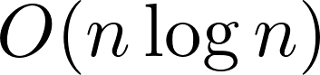

Approach2: 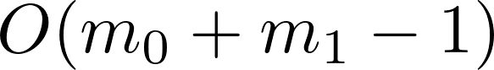

Problem 1B

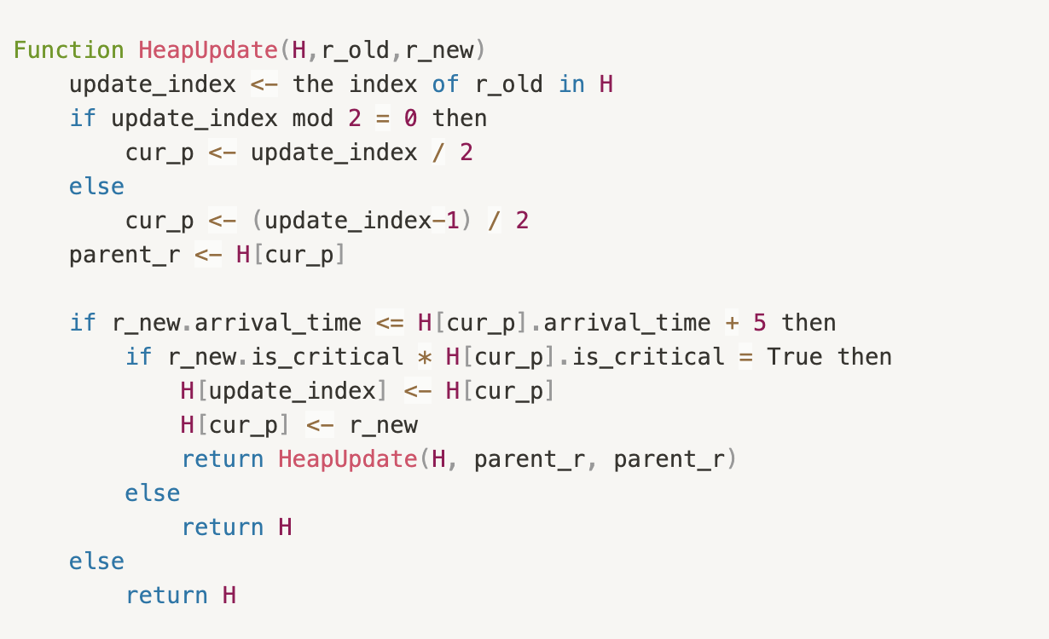

Problem 1C

Incorrect example: [_,3,5,4,5,6,4], where k = 4.

Correct example:[_,3,5,4,6,8,7], where k = 4.

Problem 2A

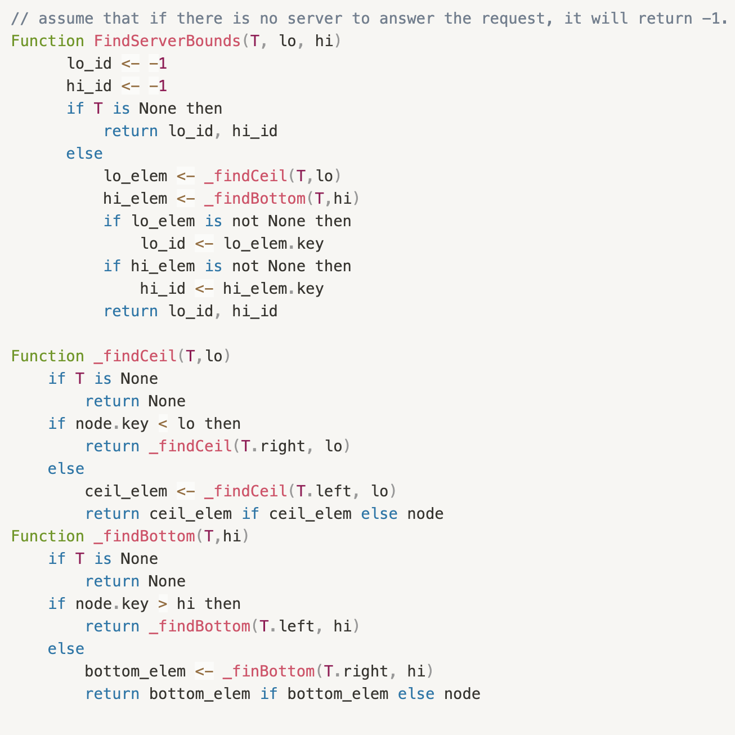

Problem 2B

Since the number of servers is k, then the height of BST is .

Also, searching the smallest and highest server ID that fall in the range [lo, hi] implements need nearly  times, respectively. Therefore, the asymptotic performance of FindServerBounds(T, lo, hi) is 